CUSTOMER JOURNEY

TITTLE NAME : Child Safety Monitoring And Notification System DOMAIN NAME : Internet Of Things (IOT)

TEAM LEAD NAME : Kumuthanayaki TEAM MEMBERS NAME : Aruna,

Jegadeesh,

Rajadurai.

**Scenario:**

Monitoring child

location



**Entice**

How child location is monitored?



**Enter**

How message is been notified to user?



**Engage**

In the core moments in the

process, what happens?



**Exit**

What do people typically experience as the process finishes?



**Extend**

What happens after the experience is over?

**Steps**



Updating of child location



Location of child sent periodically



Review of

application



Alert

parents



Create a web application



Parent can create geofence



Check whether child is inside geofence

**Interaction**

Guiding

child

Interacting with child

Parent needs are meet

Regular

updates

Setting

geofence

Connection

terminated when gps is

of

Regular

monitoring

Geofence need to be set

**Goals and motivation**



Monitori

ng child



Prevent child missing



Notifying when child crosses geofence



Taking care of child in absence



Location

is sent



Geofence

location is

set

**Positive moments**



Happy

parents



Child taken care without caretaker



Less expensive



User friendly

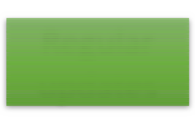

Regular updates

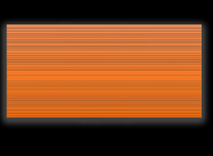

Regular updates not sent



More features to be added

**Negative moments**

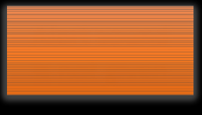

Alert sound is not given



GPS location is not proper

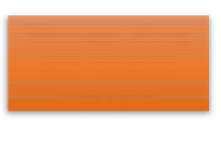

Message along with location not sent

**Areas of**

Reviews may

not asked

frequently

Where no one is able to take care of child

Alternate options

if message not sent

Alert sound along with massage

In absence of caretaker

Periodic updates of child location

**opportunity**